Why should you Proofread your resume before sending it out?
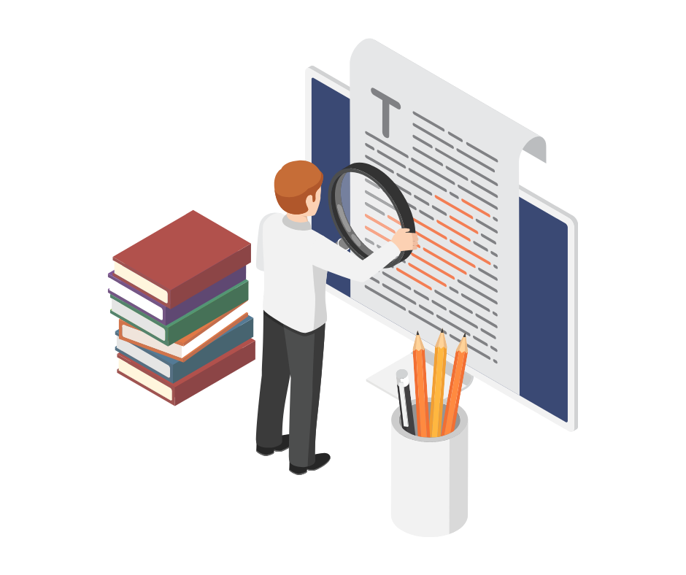

The most valuable thing you can make is a mistake – you can’t learn anything from being perfect.
Adam Osborne

Humans make many mistakes each day, but the true essence lies in learning from those mistakes. Resume Writing is a task not many people enjoy. In such a case, it is very easy to make mistakes while writing a resume.
While you cannot avoid making mistakes, you can work towards learning from those. This is possible only when you proofread your resume. Proofreading your resume ensures that it effectively describes your skills & experiences, enhances your credibility as a candidate & increases your chances of securing interviews & job offers.
It is a crucial step in the job application process that should not be overlooked. This blog will discuss the importance of proofreading your resume format enabling you to craft a ‘Perfect Resume’.

Ensures Accuracy
Proofreading your resume ensures that all information that you have added such as contact details, employment dates as well as educational qualifications are up to date & reliable.
Errors in these details can create confusion & misunderstandings potentially harming your chances of being contacted for an interview.

Enhances Clarity
A resume should be easily readable & should avoid long paragraphs. Clear, well-structured sentences & bullet points make it easier for recruiters to understand your accomplishments & qualifications quickly.
Proofreading can help you improve the content in a way that supports or enhances readability. Due to this, recruiters are more likely to read your resume without skipping it.

Maintains Professionalism
Mistakes & errors in the resume reflect your unprofessionalism & careless attitude. It leaves a bad impression on your recruiters, forcing them not to read any further.
A carefully proofread resume reflects your commitment & respect for the job application process. It shows that you value the opportunity & have taken the time to present yourself in the best possible light.

Prevents Miscommunication
Poorly phrased sentences or broken language can lead to misunderstandings about your skills or experiences. They can distract readers from the content supposed to be displayed.
Proofreading helps ensure that your resume accurately represents your qualifications. This way you can communicate your skills & achievements more effectively

Enhances Credibility
Attention to detail is a skill that is demanded by recruiters. Typos & grammatical errors can detract from your credibility & attention to detail.
A well-proofread resume demonstrates your communication skills & ability to present yourself effectively. This presents you as a trustworthy person.

Avoids Embarrassment
Who would like to be embarrassed in front of their potential managers? Not you, definitely! Proofreading your resume can save you from a huge embarrassment that can happen due to typos & spelling mistakes.
A clean, error-free document increases your chances of making a positive impact & leaving your mark in the recruiter's mind.

Increases Effectiveness
Does your resume mention that you have studied at a renowned university? But still, you manage to misspell the name of your degree. In such a case, would anyone believe you have that degree?
Proper spellings are required to effectively communicate your position in the industry you are applying for. It helps to best showcase what you bring to the table.

Helps Build an ATS-friendly Resume
Today’s competitive job market forces people to stand out amongst their peers. Recruiters get millions of applications which they must scan through. For this, they take the help of Applicant Tracking System (ATS).
Proofreading your resume will help you to add those keywords that are relevant to the position you are applying for. This way, your resume would not be stuck in the clutter but make its way out guaranteeing you the job.
Read this blog to know what is an ATS-Friendly resume.

Conclusion
Continuously applying for jobs is no fun until you know the secret to master resume writing. Want to make this job easier?
PaintMinds is here to help. With the free resume builder, unlock the benefits of getting your free resume score & LinkedIn Profile Optimization with the help of PaintMinds. Start building your career right away.

Keywords: Proofread | Resume Format | ATS friendly resume | What is an ATS- Friendly resume | Free resume score | LinkedIn Profile Optimization
Title Tag: Benefits of proofreading your resume.
Meta Description: Have you sent out your resume to various companies but received offers from none? Maybe you are not proofreading your resume. Proofreading is a crucial step in the job application process that should not be overlooked. This blog will discuss the importance of proofreading your resume format enabling you to craft a ‘Perfect Resume’.
Meta Tag: Reasons why you should not overlook proofreading your resume | PaintMinds

